Talking about numbers in English

I) Let’s revise how to talk about numbers in English:

French | English
4
40
405
4450
26758
392965
42675891
1000000
1000000000
28K
Le 1er
Le 2nd
Le 3ème
Le 25 ème
Le 51 ème
Une fois
Deux fois
Trois fois
Vingt fois
30%
10,5%
7,4%
La reine Elizabeth II

II) Read the following text out loud and practice about your skills with numbers:

Texting Statistics That Answer All Your Questions
Kenneth Burke https://www.textrequest.com/

How many texts do people send?
Americans send roughly 26,033,333,333 (26 billion) text messages every day.
On average, each American sends and receives 94 text messages per day.
On average, each American sends and receives 2,819 text messages per month.
On average, each American sends and receives 33,834 text messages per year.
1,084,722,222 texts are sent every hour in the United States.
18,078,704 texts are sent every minute in the United States.
301,312 texts are sent every second in the United States.
Sources: Statistic Brain Research Institute, Text Request

How many texts do teenagers send?
American teenagers send and receive 67 text messages per day, on average.
American teenagers send and receive 24,120 text messages per year on average.
Source: Pew Research Center

How much time do people spend texting?
American spend as much as 55 minutes a day texting. Americans spend twice more time texting than emailing on their phones.
College students spend an average of 94.6 minutes texting per day.
Sources: Text Request, Ericsson, RealityMine and AdWeek, PsychCentral, Psychology of Popular Media and MarketWatch, Gallup

III) Your own personal statistics:

Time to put your skills into practice!
You are going to write five statistics about yourself concerning the past five years.
Manipulate, big and small numbers and don’t be afraid of big numbers :)

→
→
→
→
→

IV) What time is it?

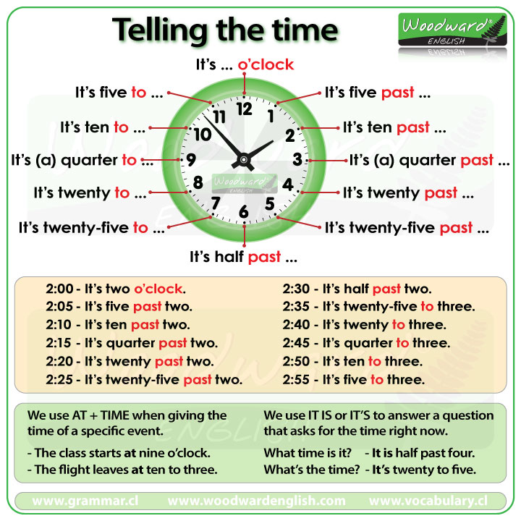
V) To put that into practice, let’s examine your ADE schedule…

Answer my questions about your weekly program….

